_____________________________________________________

Tropical Cyclone Variability in the Western Pacific since 1993

_____________________________________________________

Joshua Coupe
5/1/2016
Tropical Meteorology

Introduction

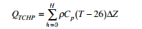
Tropical cyclones require a number of ideal conditions to form. In a previous study, the oceanic component of tropical cyclogenesis as examined. Tropical Cyclone Heat Potential (TCHP) is defined as the total heat content of a column of ocean from the surface down to the depth of the 26° C isotherm (Wada, 2007). The equation for TCHP is given as:

where $ρ$ is the density of water, approximately 1000 kg/m³, Cp is the specific heat of water at constant pressure (4186 J/kg°C), T is the temperature of the ocean in celsius, and $Δ$Z is the depth of the ocean layer in meters (Wada, 2007). TCHP depicts potential a column of water has in providing fuel to a tropical system. The units associated with this metric are KJ/cm². However, TCHP is only the oceanic component and an analysis of this metric ignores the all important atmospheric part of tropical cyclogenesis. Various mechanisms act to establish a disturbance that can then use the TCHP energy to become a tropical cyclone. In the northwestern Pacific, thermodynamic and dynamic components are necessary for cyclogenesis. A thorough investigation of the atmospheric components of tropical cyclogenesis are explored to attempt to explain a negative correlation between ACE and TCHP in the northwestern Pacific.

Methods
The global ocean model reanalysis GLORYS2V1 was used to calculate TCHP for the western North Pacific over the time period 1993 to 2012, a time with a decline in tropical cyclone frequency and accumulated cyclone energy (ACE). Over the same time, TCHP was shown to increase (Figure 1). TCHP and ACE are negatively correlated in the northwestern Pacific. This result from a previous paper inspired the investigation of the atmospheric component of the tropical cyclogenesis equation for the northwestern Pacific where an overabundance of oceanic heat exists. Peer reviewed research points towards the monsoon trough and monsoon gyres as the atmospheric drivers of variability in tropical cyclogenesis in the northwestern Pacific region (Briegel and Frank, 1996) (Lander, 1995) (Huijun and Liguang, 2014) . The goal is to estimate how variations in the monsoon trough in the northwestern Pacific, acting in conjunction with changes in TCHP, caused variations in tropical cyclone activity in this area of the world. A discussion of what modulates the monsoon trough will be the main focus of this paper.
The Monsoon Trough
The monsoon trough is a convergence zone in the western Pacific originating from southeast Asia between May and September (Lander, 1995). This monsoon trough is between the equatorial westerlies and the trade wind easterlies, a region of convergence (Lander, 1995). It is characterized by high mid-level relative humidity, strong low level cyclonic relative vorticity, and weak vertical wind shear (Hujiun and Liguang, 2014). These characteristics are also ideal for the formation of tropical cyclones, which is why the monsoon trough and areas around it are important for researching tropical cyclogenesis (Lander, 1995). The monsoon trough moves northward throughout the year, but its monthly variability is not the focus of this study, although it can be seen in Figure 2. Molinari and Vollaro (2013) found that 73% of all tropical cyclones that formed between July and November were formed within the monsoon trough for the years between 1988 and 2010. In this study, the monsoon trough was defined as a region with positive long term 850mb relative vorticity between July and November, not allowing for the distinction between formation in the monsoon trough and the monsoon gyre (Molinari and Vollaro, 2013). However, both establish easterly vertical wind shear, which is more favorable for tropical cyclone formation compared to westerly vertical wind shear (Molinari and Vollaro, 2013). The two systems are inextricably linked and vary in similar ways with the climate modes that will be discussed.
Large Scale Influences on Tropical Cyclogenesis
The formation of tropical cyclones requires both a thermodynamically and dynamically favorable environment. Mechanisms which create a favorable environment include upper level troughs, low level wind surges, pre-existing tropical cyclones, and wave disturbances (Briegel and Frank, 1996) It has been hypothesized that external forcing on the synoptic scale is almost always necessary. One external forcing is westerly wind surges, defined as “inward propagating regions of enhanced low level inflow” by Zehr (1992) An increase in southwesterly winds was shown to enhance the circulation of an incipient disturbance formed by the monsoon trough, given sufficient surface vorticity. (Briegel and Frank, 1996) A flow of this direction in the northwestern Pacific provides low level convergence and deep uplift. The remnants of a tropical cyclone are often associated with southwesterly wind surges into a new genesis area.
Reverse Oriented Monsoon Trough (RMT)
During typical conditions the monsoon trough is oriented northwest to southeast (Figure 3). However, once a typhoon season a reverse oriented monsoon trough (RMT) forms with a more zonal orientation, typically associated with the mei-yu pattern or ‘plum rains’ (Lander, 1995). In this configuration, tropical cyclones have more northerly tracks and tropical cyclone activity is often diminished altogether. Harr and Wu (2011) suggested a relationship between La Nina conditions and a more prominent RMT, but research has been limited on the variability of the RMT with respect to tropical cyclones.
Tropical Upper Tropospheric Troughs
The tropical upper tropospheric trough (TUTT) is an upper level feature which has been shown to affect the mean tropical cyclogenesis location in the northwest Pacific (Figure 4). 65% of upper level troughs in the vicinity of a tropical cyclone were stationed northwest of the genesis location (Briegel and Frank, 1996). Most tropical cyclones were observed to form within the confluence zone of the monsoon trough, which often experiences synoptic scale lifting due to the presence of the upper level trough (Wang and Wu, 2016). Upper level troughs can interact with low level circulations by forcing upper level vorticity advection. Although this may not be enough to spark tropical cyclogenesis, it can help the disturbance by providing large scale lifting. Additionally, the TUTT can inhibit the formation of tropical cyclones if it ventures too far west, as it does in La Nina years (Wang and Wu, 2016) The mean longitude of the TUTT is 160 degrees east (Wang and Wu, 2016). In years where it is more west, it introduces an abnormally dry air layer to the middle troposphere and can cause subsidence.
ISO and the Monsoon Trough
- Madden Julian Oscillation (MJO)
The Madden Julian Oscillation (MJO) is associated with eastward propagating areas of large scale convection over a time period of 30 to 60 days (Li and Zhou, 2012). During the convective phase of the MJO, tropical cyclone formation is found to increase (Li and Zhou, 2012). Tropical cyclogenesis in the western North Pacific was found to be statistically enhanced during MJO phases 1,2 and 7,8, even after removing the signature of the tropical cyclone itself (Li and Zhou, 2012). This shows that the MJO is directly responsible for creating a favorable environment for the organization of convection into a tropical cyclone in the western north Pacific by increasing low level vorticity (Huijun and Liguang, 2015). In fact, 23% of all tropical cyclones in the northwestern Pacific can be linked to the influence of an active MJO (Li and Zhou, 2012). In MJO phases 3 through 6, convection is suppressed and many of the tropical cyclones that form are at higher latitudes (Li and Zhou, 2012). It has been hypothesized that MJO’s relationship with ENSO may influence these correlations (Tam and Lau, 2005).
During the peak of a warm ENSO event, there is enhanced activity of the 850mb zonal wind east of the international dateline (Tam and Lau, 2015). This orientation characterizes a more easterly MJO envelope intruding into the Central Pacific and will lead to the formation of tropical cyclones that take on a longer track over the warm western North Pacific (Tam and Lau, 2015). This scenario typically leads to more intense tropical cyclones and this pattern can be related to the warm ENSO phase in general.
B. Quasi BiWeekly Oscillation (QBWO)
The QBWO is an oscillation on the scale of 10 to 20 days linked with the intraseasonal variability of the summer monsoon in India (Chen and Sui, 2010). It is characterized as a westward moving coupled anticyclonic and cyclonic system in the western north Pacific. Chen and Sui (2010) link the QBWO to equatorial Rossby wave dynamics, which generate a feature stronger than the MJO and at a higher frequency. The QBWO is linked to the onset of the Indian monsoon, as its propagation can influence convection distribution in the South China Sea (Chen and Sui, 2010). As the QBWO sets equatorial Rossby waves into motion, they approach the monsoon trough region with easterly vertical wind shear which can act to trap the waves and generate an organized system out of this incipient disturbance (Chen and Sui, 2010).
20% of tropical cyclones are associated with an active QBWO state and the absence of an active MJO (Li and Zhou, 2012). However, when the MJO is in phase 1,2 or 7,8 and the QBWO is active is when 43% of observed tropical cyclones form (Li and Zhou, 2012). Both the QBWO and the MJO come together to form the ISO, or the IntraSeasonal Oscillation. The MJO and QBWO influence how the background environment in the northwestern Pacific interacts with the monsoon trough and thus heavily influences the number of tropical cyclones that are able to form at any given time.
El-Nino Southern Oscillation and Tropical Cyclones
The El-Nino Southern Oscillation acts in conjunction with the intraseasonal oscillation but can force very distinct signals on tropical cyclone interannual variability in the northwestern Pacific. Because ENSO leads to warmer SSTs in the central and eastern Pacific, disturbances propagating over these regions are expected to accumulate more energy give sufficient atmospheric conditions (Camargo and Sobel, 2005). Lifespan of tropical cyclones has been shown to increase during warm ENSO years as more tropical cyclones form in the central Pacific and propagate the across the basin towards the Asian continent (Camargo and Sobel, 2005). The central Pacific becomes enhanced both thermodynamically and dynamically for tropical cyclogenesis for various reasons during a warm ENSO phase.
According to Chan and Liu (2004), warmer SSTs in the northwestern Pacific are correlated with weaker 850 mb relative vorticity in the western Pacific, which would suggest that warm SSTs are linked to unfavorable dynamic conditions for tropical cyclones. Further examining this correlation in only ENSO years eliminates this connection, exposing the warm phase of ENSO’s role in creating atmospherically favorable conditions for long lived tropical cyclones (Chan and Liu, 2004). The atmospheric component of ENSO leads to both a reduction in the moist static energy to the northwest of the monsoon trough as well as an increase in moist static energy to the southeast of the monsoon trough (Chan and Liu, 2004). This enhances deep moist convergence southeast of the monsoon trough while significant subsidence occurs northwest of the monsoon trough (Chan and Liu, 2004). Warm ENSO events shift the positioning of the monsoon trough towards the southeast, providing dynamically favorable tropical cyclone conditions (Chan and Liu, 2004). Chan and Liu (2004) conclude that the main relationships between tropical cyclones and ENSO are not with warmer SSTs, but due to modulations in the strength of monsoon trough (Chan and Liu, 2004). Creating favorable atmospheric conditions in the central Pacific allows for westward propagating storms to have longer lifespans which can interact with warmer SSTs.
The increased frequency in long lived storms increases the potential for greater accumulation of accumulated cyclone energy (ACE). ACE has also been positively correlated with certain ENSO indices (Camargo and Sobel, 2005). Of 13 El Nino years studied between 1950 and 2002, only one recorded ACE values below the median (Camargo and Sobel, 2005). Cold ENSO years were shown to have lower ACE values on average via this same study. ACE is closely related to tropical cyclone intensity, showing that warm ENSO years see a shift to more ACE per tropical cyclone while cold ENSO years see a shift to less ACE per tropical cyclone (Camargo and Sobel, 2005). Cold ENSO years are observed to have frequent tropical storms that are very weak on average (Mei et al., 2015) . In the opposite phase, the spatial distribution of tropical cyclones has been documented to shift southeast during warm ENSO phases due to the changes in the monsoon trough as discussed before (Camargo and Sobel, 2005). SST as a major factor for long term variability was ruled out by Chan and Liu (2004), leaving the monsoon trough-tropical upper tropospheric trough system as the main modulator in interannual variability in tropical cyclones.
Quantifying the Interannual Variability: ENSO and the TUTT
Wang and Wu (2016) discovered a robust link between 'west years' and 'east years' of the TUTT and cold and warm phases of ENSO, respectively. In 1995, 1998, and 2010, the TUTT was observed to be at its most westerly point (Wang and Wu, 2016). In these years, tropical cyclone development was inhibited and a cold ENSO phase was observed. In 1994, 1997, 2002, and 2004, tropical cyclone formation was enhanced (as seen in the increases in ACE in Figure 1), correlating well with warm ENSO years (Wang and Wu, 2016). Variations in the TUTT are ultimately influenced by SST variations across the Pacific which are integrated into ENSO (Wang and Wu, 2016). In ‘east years’, warm SSTs in the Central Pacific impact the Walker Circulation, extending the monsoon trough to the east (Wang and Wu, 2016). A more easterly monsoon trough coupled with warmer ocean temperatures leads to greater accumulation of ACE over the course of a season (Wang and Wu, 2016). As a result of this analysis, it seems clear that surface conditions over a large area can influence the upper levels and drive changes in the monsoon trough.
Quantifying the Decadal Variability
Given that oceanic heat content has a negative correlation with ACE in the northwestern Pacific over a 20 year period (Figure 1), it is clear that a climate regime has been active to create unfavorable conditions for tropical cyclones in the northwestern Pacific. On an interannual scale, ENSO is clearly driving variability in ACE through modulations in the monsoon trough and he TUTT. However, the negative decadal trend can be partially explained through variations in the Pacific Decadal Oscillation (PDO). On very large timescales, the spatial distribution of SSTs associated with a negative PDO creates an anticyclonic anomaly over the northwestern Pacific (Zhao and Wang, 2015). Whether or not the monsoon trough has a characteristic signature over decadal timescales has yet to be uncovered. However, an anticyclonic anomaly over the typical area of tropical cyclogenesis would in any case be harmful for the development of tropical cyclones.

Conclusion
The interannual and decadal variations in atmospheric circulations, which are often influenced ocean heat content, drive tropical cyclone development through altering the position of the monsoon trough. The QBWO, MJO, TUTT, ENSO, and PDO act on ACE by creating regions that inhibit or enhance tropical cyclogenesis over seasonal, annual, and decadal timescales. All of these processes work together to shape each year’s typhoon season and understanding how they work together assists in long and short range predictions.

Figures
Figure 1: Tropical Cyclone Heat Potential averaged annually over May to September in the northwestern Pacific between 1993 and 2012 with ACE over the same time period.
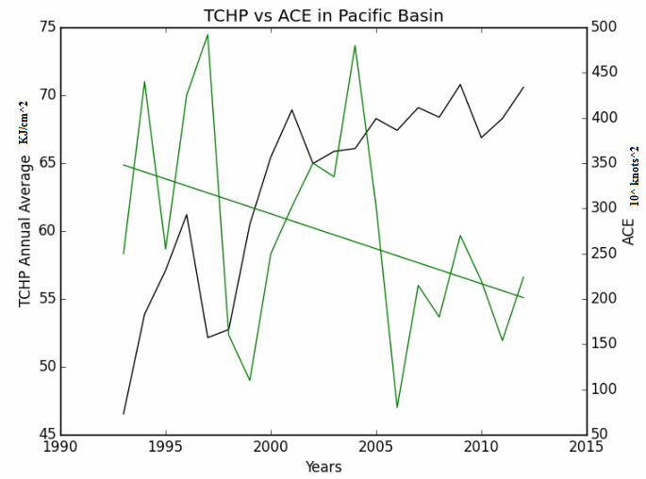

Figure 2 - The seasonal variation in the monsoon trough in the northwestern Pacific Ocean taken from Lander, 1995
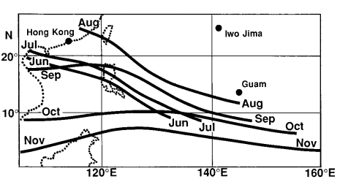

Figure 3 - The normal monsoon trough (top) and the reverse oriented monsoon trough (bottom). Taken from Lander, 1995
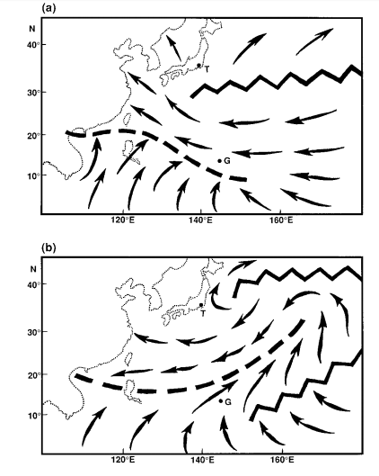
Figure 4 - The NCEP reanalysis of the northwestern Pacific Ocean demonstrating the tropical upper tropospheric trough from averaged from June to August.
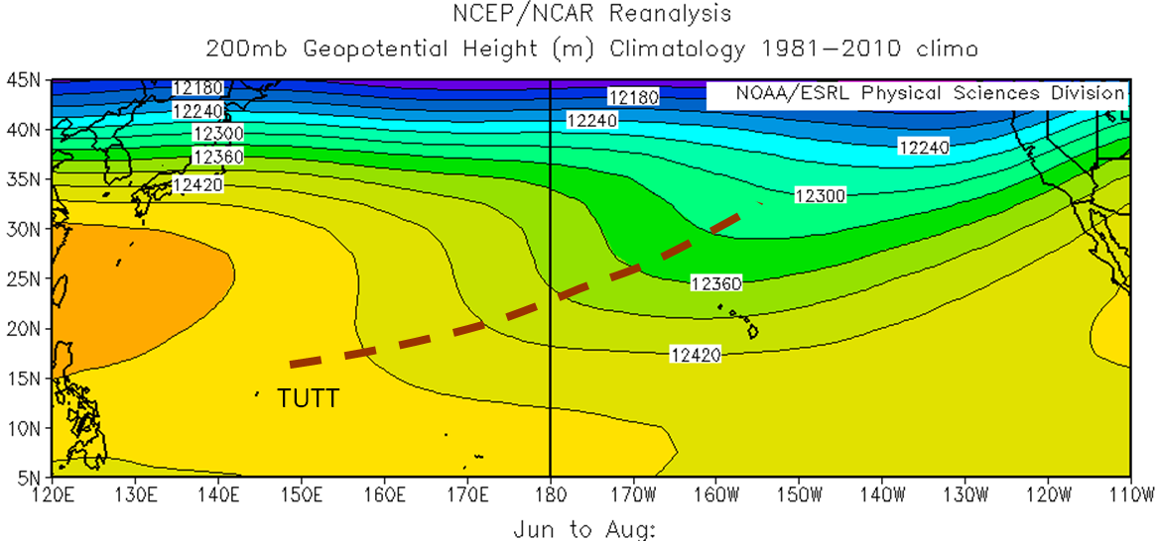
Figure 5-The Pacific Decadal Oscillation (PDO) from the National Climatic Data Center, showing the prominent negative cold phase since the mid 1990s.
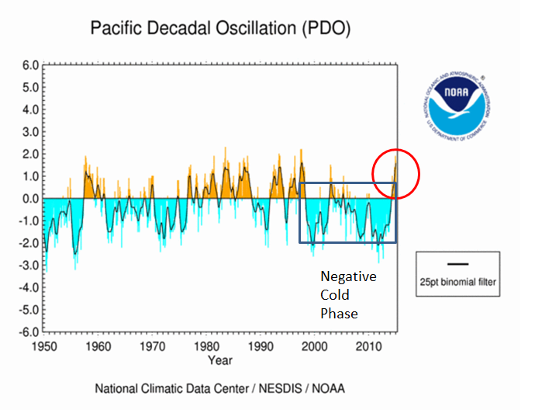

References
Briegel, L. and Frank, W. 1996. Large-Scale Influences on the Tropical Cyclogenesis in the Western North Pacific. Monthly Weather Review, pg 1397-1413.

Camargo, S. and Sobel, A. 2004. Western North Pacific Tropical Cyclone Intensity and ENSO. Journal of Climate, Vol. 18, pg 2996-3006.

Chan, J. and Liu, K. 2004. Global Warming and Western North Pacific Typhoon Activity from an Observational Perspective. Journal of Climate. Vol 17. pp 4590-4602

Chen, G., Sui, C. 2010. Characteristics and origin of quasi-biweekly oscillation over the western North Pacific during boreal summer. Journal of Geophysical Research. Vol 115.

Chen, T., Wang, S., Yen, M. 2006. Interannual Variation of the Tropical Cyclone Activity over the Western North Pacific. Notes and Correspondence. Pg 5709-5719.

Harr, P., Wu, C., 2011. Tropical Cyclone Characteristics and Monsoon Circulations. The Global Monsoon System: Research and Forecast (2nd Edition).

Huijun, Z. and Liguang, W. 2014. Re-examination of Tropical Cyclone Formation in Monsoon Troughs over the Western North Pacific. Advances in Atmospheric Sciences, Vol. 32, 924-934.

Lander, M. 1995. Specific Tropical Cyclone Track Types and Unusual Tropical Cyclone Motions Associated with a Reverse-Oriented Monsoon Trough in the Western North Pacific. Weather and Forecasting, Vol 11, pg 170-186.

Li, R. and Zhou, W. 2012. Modulation of Western North Pacific Tropical Cyclone Activity by the ISO. Part I: Genesis and Intensity. Journal of Climate, Vol. 26, pg 2904-2918.

Mei, W. et al. 2015. Northwestern Pacific Typhoon Intensity Controlled by the Changes in Ocean Temperatures. Sci. Adv.

Molinari, J. and Vollaro, D. 2013. What Percentae of Western North Pacific Tropical Cyclones Form within the Monsoon Trough. Monthly Weather Review.

Ritchie, E. and Holland, G. 1998. Large-Scale Patterns Associated with Tropical Cyclogenesis in the Western Pacific. Monthly Weather Review, pg 2027-2043.

Stowasser, M., Wang, Y., Hamilton K. 2006. Tropical Cyclone Changes in the Western North Pacific in a Global Warming Scenario. Journal of Climate, Vol. 20, pg 2378-2396.

Sui, M., Murakami, H., Yoshimura, J. 2009. A Reduction in Global Tropical Cyclone Frequency due to Global Warming. SOLA, Vol. 5, 164-167.

Tam, C and Lau, N. 2005. Modulation of the Madden-Julian Oscillation by ENSO: Inferences from Observations and GCM Simulations. Journal of the Meteorological Society of Japan, Vol. 83, No.5, pp. 727-743.

Wada, A. and Usui, N (2007)., Importance of Tropical Cyclone Heat Potential for Tropical Cyclone Intensity and Intensification in the Western North Pacific, Journal of Oceanography, 63, 427-447

Wang, C. and Wu, L. 2016. Interannual Shift of the Upper Tropospheric Trough and its Influence on Tropical Cyclone Formation over the Western North Pacific. Journal of Climate.

Zhao, H. and Wang, C. 2015. Interdecadal Modulation on the Relationship between ENSO and Typhoon Activity during the Late Season in the Western North Pacific. Climate Dynamics.

