The Effects of Ground Level Ozone on Children with Asthma

An Analysis of Ambient Ozone and its Correlation with Asthma Related Hospitalizations in Children

Tag Words: Asthma, ozone, climate change, ground level ozone, air pollution

Authors: Joshua Coupe, Valerie DeJesus with Julie M. Fagan, Ph.D.

Summary: High concentrations of ground level ozone may trigger asthma attacks and worsen asthma symptoms. On days where there is high ozone concentration, there are increased reports of hospitalization visits of children due to asthma. Decadal and interannual variability in ozone concentrations on a national and regional level can be used to project how ozone will change into the future. Future projections of ozone concentrations allows us to predict the frequency of hospitalizations due to asthma by location.

Video Link: https://youtu.be/2a3Oy2eeN8U

The Issue: Childhood Asthma as it relates to Ground Level Ozone Exposure (VD)

Asthma is one of the most common and serious chronic lung diseases. Asthma is characterized by difficulty in breathing normally due to inflamed airways upon a response that is known as an asthma attack. Asthma attacks are a sudden onset of symptoms such as shortness of breath, coughing and wheezing which elicit a narrowing of the bronchi due to the smooth muscle surrounding the bronchi to constrict (1). Though there is no cure for asthma the symptoms can be alleviated and managed. Despite these remedies, there is still a large amount of asthma related hospitalizations. The prevalence and new incidence of childhood asthma especially have been increasing rapidly nationally. Asthma has both genetic and environmental factors (2). Though, persons who have parents that have asthma are more likely to develop asthma themselves, environmental triggers play a larger role in the development of asthma. One environmental trigger in particular that is not very well known is ground level ozone. This paper serves to explore the correlation between increased ground level ozone and asthma related hospitalizations of children.

How Prevalent is Childhood Asthma: Demographics & Statistics (VD)

According to the Center for Disease Control, about one in eleven children have asthma. That is roughly seven million children nationwide (3). Asthma is a serious health concern that is costly and can interfere with daily obligations such as school and work. The Center for Disease Control estimates that in the United States asthma costs $56 billion each year, which is an average of $1,039 per child with asthma (3). Experts also estimate that asthma caused about 10.5 million absences from school (3). In order to better understand asthma’s effects on children, this paper will attempt to analyze and compare asthma with child age groups, sex, and race/ethnicity. All data references can be located in Table 1 in the appendix.

In analyzing childhood asthma in correlation to age groups, it appears that children ages 5-11 and 12-17 have the highest asthma prevalence at 9.8% and 9.9%. In the comparison between males and females, female children have a higher prevalence of 7.3% compared to their male counterpart at 6.2%. Dissecting these groups further by racial and ethnic categories we see that non-Hispanic Whites and Hispanic children have similar prevalences at 7.5% and 7.4%, respectively. Other non-Hispanic children have a prevalence slightly higher at 7.9%. However, when looking at black children, asthma prevalence is 13.4%, which is substantially higher. This high percentage may also have other contributing factors such as socioeconomic, geographic location of residency and many other variables. Statistically speaking, it is more common to see non-Hispanic Blacks living in areas that have a higher total concentration of air toxins (4). This may have positive correlation with asthma prevalence in black citizen who live in metropolitan areas. Similar to the percentage per population, in analyzing Puerto Rican children, their asthma prevalence is 14.6%. This statistic is supported by research done by the Robert Wood Johnson Foundation, which stated that this is the highest prevalence of asthma among children. One of the lower prevalences is seen with Mexican/Mexican American children at 5.6%.

These numbers are telling of the severity of asthma and its growing prevalence, especially in minorities such as Blacks and Puerto Ricans. In relation to environmental hazards, such as ground level ozone, children are the most vulnerable when inhaling such pollutants (5). Studies say that children are particularly at risk due to the fact that children have a relatively higher amount of air inhalation in relation to body weight. Also, the fact that children do not have a fully developed immune system or lungs works against them upon inhaling harmful air pollutants. These factors considered, researchers at the World Health Organization suggest that children consequently have a substantially higher exposure to air pollutants that adults (5). In order to put this in greater perspective, it is necessary to further discuss what happens upon inhalation of ground level ozone specifically by children.

Asthma Attacks: A Cascade of Cellular Events (VD)

In order to understand the mechanisms that occur when ozone specifically is inhaled, it is important to have an understanding of what generally happens when other common triggers enter the body to provoke an asthma attack. Asthma attacks are the result of an immune system response. As soon as the immune systems becomes aware of the allergen, it signals other cells to create antibodies specific to that allergen. Other symptoms that result from this process, besides the narrowing of the airways, are watery or itchy eyes and runny nose (6).

Another type of cellular product that arises after being exposed to an allergen is immunoglobulin E (IgE). Upon inhaling an antigen, the particle inducing the attack that is foreign and harmful, your immune system responds almost instantaneously. Allergens are processed by antigen presenting cells (APC) and from a complex made of peptide fragments with Major Histocompatibility Complex (MHC) II. This promotes the maturation of T cells into Th2 cells which eventually produce Cytokines. These Cytokines result in the production of IgE from B cells. IgE then bind to receptors on mast cells. This results in a change of the mast cell permeability and a release of inflammatory mediators. These inflammatory mediators include substances such as histamine, serotonin, leukotrienes, prostaglandins, carboxypeptidase A, platelet activating factors (PAF), cathepsin G, neutrophils and eosinophils. The release of these inflammatory mediators contribute to the early responses that come about within seconds of exposure to the allergen (7). This cascade of cellular events that results inflammation, and thereby, narrowing of the airways causes an asthmatic to experience tightening of the chest, coughing and wheezing (8).

Ozone and Other Common Asthma Triggers (VD)

There are a wide range of triggers that can elicit an asthma attack. Some common asthmatic triggers are allergens (pollen, mold, animal dander, dust mites), exercise, occupational hazards, tobacco smoke, airway infections and air pollution, such as ozone pollution (9). Ozone (O₃) is a strong oxidant that is harmful to all biological tissues, especially the lungs, as it is known to evoke and increase in medication use, illness and, in severe cases, death (5). Many scientific research has shown that inhaling ozone can be detrimental to human health. Scientists are reporting that there is no safe level of inhalation of O₃ because findings are suggesting that even very low concentrations have potential health risks (5). Since ozone can trigger an asthma attack, it must then be classified as an antigen. In fact, inhalation of ozone initiates the same immune response as any other allergen when inhaled. Ozone has been found to cause inflammation not only of the airways, but of the lungs as well (10).

Ozone Inhalation and the Body’s Response (VD)

There is evidence that ozone acts in parallel to other asthma triggers as well as independently, causing other bodily dysfunctions and comorbidities. One study that provides support for the similarities of ozone to other asthma triggers is one done by a group of Korean researchers in 2011. Through statistical analysis, the team graphically represented the correlation of ozone concentration per designated concentration quartiles and IgE levels (Figure 1). The graph shows significant increases in IgE levels in relation to a small concentration of ozone (quartile 1-2: 15-20 ppb) and a large amount of ozone (quartile 3-4: > 25 ppb). The level of IgE that resulted from the concentrations of quartile 1-2 remained the same from quartile 2-3 (20-25 ppb).The team concluded that children exposed to higher concentrations of ozone has an increased level of total IgE (11). These findings support the notion that ozone acts similar to other asthma triggers.

Though ozone inhalation evokes the same cascade of cellular events discusses in a previous section, there are also unique occurrences that happen when O₃ is introduced in the body. According to researchers, lung function immediately decreases upon inhalation of ozone (12). Ozone acts in similar ways to other asthma triggers in that it promotes irritation of the airways and results in the same asthma symptoms (13). Though, there are also bodily effects that are specific to ozone. One unique occurrence is how exposure to ozone can have a trickle down affect and impair or alter coagulation (12). The inflammation of the lungs due to ozone has been observed to disrupt fibrinolysis pathways that normally work to break down blood clots in the body. The impairment of this process can cause dysfunctions in the cardiovascular system (12).

One of the major, and potentially most harmful, differences is that inhalation of ozone can provoke cellular oxidative stress. Oxidative stress can be caused by an accumulation of reactive oxygen species in the body or by impairing the ability of antioxidant systems to clear free radicals from the cells, which is the mechanism that ozone inhalation triggers (14). Since ozone is a major oxidant, it has the potential to do significant damage in vivo, particularly by forming free radicals (15). Normally, a cell utilizes oxygen for cellular respiration. The result is the formation of energy, in the form of ATP, and the reduction of oxygen to water. The introduction of a strong oxidant, such as ozone, can disrupt this process and yield free radicals.

There are cellular functions in place to inhibit the damaging effects of free radicals, called antioxidant systems, however, exposure to ozone can hinder these compensatory processes. Free radicals cause numerous cellular dysfunctions such as loss of functional groups on major enzymes, a changed membrane permeability and can ultimately lead to cell injury or death (15). Also, if left unchecked by other cellular processes, free radicals can cause normal cells to mutate into cancerous ones. These adverse effects can be witnessed in the cells that line the airways and that make up the alveolar region of the lungs even with acute exposures to O₃ (15). If such adverse events can arise from acute exposures to ozone, one can further extrapolate that the effects will be greater in cause of chronic exposures. One such study correlated long term exposures to ozone with hindered development of lung function in children (16).

Oxidative stress not only initiates the mechanisms of pulmonary inflammation in lung epithelial cells, but it can also provoke carcinogenic mechanisms as well (17). The promotion and development of pulmonary cancers have been linked with oxidative stress and other cellular dysfunctions caused by oxidative stress such as DNA damage, stimulation of macrophages, induced telomere shortening, alteration of gene expression and other factors that feed into carcinogenesis (17).

An important note is that though most of these studies analyze children with preexisting asthma, not all of them do. One study that focuses on children who have no pre-existing lung ailments found evidence to suggest that healthy children also suffer from a decrease in lung function upon inhalation of ozone (18). The study exposed children to sub-chronic levels of ozone and found that even in acute levels, there were decreases in the amount of air capable of being expelled from the lungs mid-expiration, thus supporting the notion of decreased lung function (18). This evidence suggests that ozone, while seemingly more negative results ensue the inhalation by a child who is asthmatic, also negatively affects healthy, non-asthmatic children. This furthers one of the purposes of this paper, which is to emphasize the importance of human action to mitigate ground-level ozone levels.

Ozone Formation: NOx and VOCs (JC)

Ozone is not directly emitted from the combustion of carbon fuels. Ozone, or triatomic oxygen, is formed as part of the reaction of NOx and ultraviolet (UV) radiation as well as the reactions of volatile organic carbons (VOCs) and UV radiation (19)(20) . The reaction begins with the requirement of molecular oxygen reacting with another mass, typically nitrogen. Ozone production is included with the nitrogen cycle when NOx is reacting with UV radiation. The nitrogen cycle, however, establishes an equilibrium which indicates that the nitrogen cycle alone does not contribute to high ozone concentrations (20). This nitrogen cycle requires a high ratio of NO₂ to NO for the runaway production of ozone to occur. An equilibrium exists unless the photochemical oxidation of hydrocarbons and aldehydes (VOCs) can provide the pathway for accumulation of ozone at the surface, which is what occurs (19).

The VOC reaction is an oxidation cycle which oxidizes VOCs, forming CO, CO₂, and H₂O. An intermediate step Hydroxyl radicals attacking hydrocarbons, the start of the oxidation process (19). Hydroxyl radicals play an important role in generating peroxy radicals, which reacts with NO to generate NO₂. This conversion is key and takes place very quickly as Hydroxyl radicals are abundant in ambient air, especially in a polluted environment with plenty of water vapor and nitrous acid. An essential reaction towards understanding tropospheric ozone production is the NO₂ radical sink reaction which forms nitric acid.

NO₂ + OH + M→ HNO₃ + M.

NO is present in the atmosphere at high concentrations in the morning because Peroxy radicals necessary for the conversion of NO to NO₂ are not present (21). When the sun rises, photolysis of formaldehyde occurs, kickstarting the VOC oxidation cycle. Peroxyl radical conversion of NO to NO₂ shifts this ratio to favor ozone accumulation at the surface (19).

The reaction of organic gases can be relatively slow, delaying the highest ozone levels until later in the day and allowing areas downwind of the greatest emissions to have the highest levels. Therefore, meteorological conditions have the final say on the amount of ozone that can build up at the surface. The deepening of the mixed layer, the layer of air just above the surface which maintains relatively uniform temperatures, can help to disperse built-up ozone. In terms of chemistry, the ratio between VOCs and NOx determines whether the NOx acts to generate or diminish ozone (21). When NOx is abundant compared to VOCs, ozone will be low. When VOC is abundant compared to NOx, ozone will be excessively generated with sufficient meteorological conditions. At night, NO and ozone combine to form NO₂, consuming NO and ozone.

O₃ + NO → NO₂ + O₂

Nitrous acid (HNO₂) can be formed as a result of the products in the above reaction. Sunlight breaks nitrous acid down, so when the sun rises the breakdown of nitrous acid can actually provide NO and OH which are key for ozone formation in the morning. Having available ozone can carry over to the following days because although ozone dissipates at night, its byproducts can help react with VOCs in the morning (19).

Occasionally, stratospheric intrusions into the troposphere can increase the concentration of surface level ozone, especially in higher elevations (22). However, this mechanism simply helps to increase the background level of ozone and is not directly responsible for the spikes seen in cities in the summer. Similarly, lightning creates ozone along the path of discharge, but meteorological conditions typical during severe weather are not associated with the buildup of ozone (22). In fact, severe weather is associated with rain and gusty winds which will disperse ozone and improve air quality. The complex chemistry of ozone formation allows for large spatial variation in ozone concentrations. Typical levels of ozone in areas far removed from anthropogenic influences are between 20 and 40 ppb (23). Rural areas downstream of urban areas have higher concentrations around 50 ppb to 80 ppb due to the transport of air high in ozone from those urban areas (23). These urban areas can see ozone concentrations greater than 100 ppb (23).

Human Emissions and Ozone (JC)

Human activity has affected the global concentrations of many gases since the beginning of the 20th century. According to Lamarque (2005), NO emissions have increased from 15.3 T per year to 73.8 Tg per year globally from 1890 to 1990. NO is vital for the creation of NO₂ which is directly related to the production of ground level ozone (Table 2).

The NO comes from direct anthropogenic emissions, soil fertilization, and increased biomass burning (22). Human contributions to gases comprising the atmosphere becomes the dominant factor in the formation of ozone. Global ozone concentration varies wildly from region to region based on emissions. Every region has sources that dominate its emissions whether that be biomass burning, combustion of fossil fuels in motor vehicles, or industry. Figure 2 shows some common sources of the compounds that allow for ozone to form. However, an increase in the globally averaged concentration of ozone increases the likelihood for larger ozone peaks in the summer of regions with high emissions of NO. The globally averaged concentration of ozone can be seen as the background noise as ozone can be transported across continents (24).

Meteorological Factors in Ozone Concentrations (JC)
Ozone concentrations are dictated by more than just atmospheric chemistry and UV radiation exposure. When ozone is formed, where it ends up is dependent upon several meteorological variables. On short timescales, winds will transport the high ozone concentrations in urban areas to more rural locations if the prevailing wind allows for such a process (25). In New Brunswick, this means that on a hot summer day with prominent warm air advection from a southwesterly flow, the ozone produced in the city of New Brunswick will head over the Raritan River to Edison and Piscataway. There are various meteorological conditions that promote poor air quality not just from ozone’s presence. When high pressure is present, this increases the likelihood of an inversion forming in the boundary layer (25). An inversion is when the temperature of the atmosphere increases with height, not allowing for air to rise much further than the boundary of that inversion because the atmosphere is too stable. Ground level air pollution sits underneath this inversion cap as pollutant concentrations increases. While high pressure and warm temperatures might indicate a nice summer day for many, it is a recipe for disaster for those suffering from asthma or other lung related conditions.

On longer timescales one can average together the meteorological conditions at a single location to predict ozone (24). Geographical location, prevailing winds, and likelihood of inversions are strong factors that determine this. The seasonal timescale is the most defined timescale by which ozone can be considered. Globally, ozone concentrations spike in the summer aided by warm temperatures, plentiful sunshine, and the greater chance of high pressure and capping inversions (24). Larger scale teleconnections can also affect ozone concentrations for large regions on long timescales. Sekiya and Sudo (2014) studied how the transport of ozone changes on an interannual and multidecadal timescale. For example, during the warm phase of ENSO (El Nino Southern Oscillation), Indonesia typically sees drought conditions which often leads to greater biomass burnings (24). As a result, ozone concentrations are seen to increase during the warm phase of ENSO, and transport of this ozone rich air is carried off in the direction of the prevailing wind (24). Multidecadal and interannual variations in ozone concentrations can be used to develop skill in predicting ozone,

Trends in New Jersey Ozone (JC/VD)

According to the New Jersey Department of Environmental Prediction, ozone concentrations have been steadily improving in New Jersey since 1984 (27)(28). Figure 3 shows how the maximum ozone concentration in any New Jersey ozone monitoring site has decreased. While weather has the most profound effect on interannual variability, long term trends in ozone are most likely attributed to economic factors as well as regulations on fuels producing NO or VOCs as a byproduct (27). In 1988 important regulatory measures were instilled at gas stations to reduce VOCs emitted into the air (29). While this may have sparked the drop in ozone concentrations for a decade, improvement has leveled off (28).

Further regulations on activities that lead to the emission of NO and VOCs could bring ozone concentrations below 80 ppb (28). One could attribute the drop in ozone concentrations in 2008 and 2009 to the economic recession, where gas was relatively expensive and leisurely driving to many became a luxury (28). This connection between gasoline and ozone may initiate fear in many looking forward to the upcoming summer, where gasoline prices are at their lowest in years. An increase in the combustion of gasoline by motor vehicles will without a doubt be a factor in increasing ozone concentrations.

Regional and Temporal Variations of Ozone (JC)

The three major trends over this time period relate to government regulation, economic conditions, and climate. The first downward trend is a function of regulations by the EPA in 1987 and 1989, where new rules at gas stations reduced VOC concentrations. Using the Japanese Reanalysis Assessment over the period of 1985 to 2015, the northeastern United States is shown to have experienced significant variability in ozone concentrations as shown in Figure 4. After the EPA regulations in the 1980s there was a decrease in ozone concentrations only for a short period of time. Variations in ozone concentrations over time can be attributed to varying emissions and rising temperatures. Figure 5 shows the May to September averaged national temperature over the same time period.

Between the years 1995 and 2007, ozone concentrations maintained relatively constant at a high level. Looking at temperature variations over this same period time of time helps to explain this trend, as temperatures rose consistently through this time period. Assisted by one of the largest El Ninos of our time as well as the extra radiative forcing from increased greenhouse gas concentrations, the global mean surface temperature as well as the United States’ mean surface temperature is increasing into the 21st century. As discussed before, high temperatures favor the rapid creation of ozone. Emissions during this same time period experienced the opposite trend where NOx concentrations in the atmosphere went down. The high ozone concentrations with low variability from 1995 to 2007 shows that high temperatures exacerbate the ozone problem despite less emissions.

National Trends of Ozone (JC)

Over the years 1985 to 2015, the national climatologically averaged ozone for May to September is shown in Figure 6. Southern California, as expected, has the most unhealthy ozone concentrations in the United States. The east coast, including New Jersey and New York City, also exhibits unhealthy ambient levels of ozone. The most asthma friendly region of the United States is the midwest in states such as Indiana and Ohio. Nationally, ozone has remained near constant over the 30 year period (Figure 7). As was the case in the northeast, emissions of ozone producing gases improved significantly over the time period, but it was rising temperatures that halted much progress (Figure 8). Over the period 1985 to 2015, temperatures rose at an average rate of around 0.8 K per 30 years, or an average of 0.0267 K per year.

Epidemiological Correlations with High Ambient Ozone Levels (JC/VD)

While the link between ozone and lung damage has been established on an individual biological level, finding the point where ozone concentrations cause enough to harm to be reflected in asthma related emergency room visits has been less simple. Many factors must be controlled to sift through the noise such as meteorological conditions and the effects of particulate pollution. However, the Weisel et al. (1995) study was able to find a correlation between higher than normal ozone concentrations and increased lung or asthma emergency room visits in central New Jersey (26). The study analyzed data from 1986 to 1990 during the summer months in central New Jersey and 8% to 34% of the total variance in emergency room visits was explained by anomalous ozone levels (26). Emergency room visits in central New Jersey occurred 28% more often when average ozone levels exceeded 60 ppb.

There has been much debate among regulatory agencies about what the acceptable level of ozone should be. The World Health Organization sets this as low as 50 to 60 ppb which is far less than the maximum values reported at New Jersey sites, even with an improving trend (26). Beyond New Jersey, a Canadian study found emergency room visits were 33% more frequent when ozone concentrations were above 75 ppb between 1984 and 1992, demonstrating very similar results (30). It was noted that many of the days studied were in fact below the critical standards set by both the United States and Canada for dangerous ozone levels. Above all, even moderate levels of ozone during the summer have created a statistically significant effect on emergency room visits for those with asthma.

Community Action (JC/VD)

A high resolution projection of ozone serves as our community action, a defense against the very air that we breathe. This projection provides a powerful tool to the public, the information which can save an asthmatic family the trouble of moving to an area that is known to experience unhealthy ozone concentrations.

Previous Projections of Ozone into the Future (JC)

Projections of ozone into the future have been attempted in a number of studies using high resolution mesoscale atmospheric chemistry models (23)(31) These endeavors provide society with the capacity to predict invisible hazards threatening the public’s health. Hogrefe et al., (2004) (23) used the Pennsylvania State University mesoscale regional climate model (MM5) and the Community Multiscale Air Quality model along with the highest emissions scenario A2 from the Intergovernmental Panel on Climate Change to predict future ozone concentrations.

Given continuous emissions growth, daily maximum ozone concentrations in the summertime of the eastern United States would increase by 2.7 ppb by the 2020s (23). This averages data over all the various landscape types found on the east coast of the United States such as city, suburb, and rural areas. The main conclusion was that while intercontinental transport of ozone can be important to increasing concentrations, addressing regional anthropogenic contributions may be the most important aspect of confronting dangerously high ozone concentrations in the summer (23). Using a model coupled with a global climate model allowed integrating warming temperatures and more frequent heat waves to more accurately project peak ozone (23).

The assumptions and conclusions from the Sheffield and Hogrefe study were used to calibrate a model assuming linear temperature rise with a constant ozone response. A linear rise in temperature is shown in Figure 9. Given that temperatures continue to rise at a trend of .0267 K per year, Figure 10 shows potential future scenarios. Temperature’s impact on ozone has been derived based on past trends and a number of different emission scenarios. Even in the most optimistic temperature scenarios where the radiative forcing of greenhouse gases is not coupled with increasing water vapor, ozone concentrations nationally can be expected to remain above levels considered dangerous by the World Health Organization. Figure 11 shows how ozone is expected to change spatially, which is a blend of projected rises in temperature and current ozone levels.

While most locations are not expected to see great increases in ozone, only the midwestern United States should experience any significant improvements. Much of the New York City metropolitan area is expected to remain above the health standards set forth by the WMO. Additionally, this is simply a projection of ozone averaged over a year, indicating that the maximum recorded ozone values recorded in a year will be higher, as it is in most cases.

Ozone Modelling with the Integration of a Morbidity Analysis (JC/VD)

Sheffield et al., (2011) (31) used a mesoscale model combined with the same emissions scenario at a higher resolution of 36 km by 36 km to model New York City ozone concentrations. The results from this scenario were combined with a morbidity analysis using a past assessment of ozone and asthma related emergency room visits at the county level. This morbidity analysis could be used to project the impact of future changes in ozone on the healthcare of New York City’s constituents. The model run found a projected increase of 2.7 to 5.3 ppb in ozone concentration among 14 New York City metropolitan area counties from the 1990s to the 2020s (31). This was found to be relatively consistent with Hogrefe et al., (2004)(23). There were greater increases in ozone in counties towards the coast, just outside the most urban areas, which was presumed to occur due to the predominant direction of the wind. The morbidity analysis determined a 7.3% increase in asthma pediatric emergency department visits attributed to ozone from the 1990s compared to the 2020s (31). However, emissions factored into the production of ozone have been decreasing according to the EPA (27).

The equation for the morbidity analysis used is as follows:

M = (P/1000) * B* ERC, where ERC = exp (b*O₃)-1.

M is the mean daily asthma related emergency room visits attributable to ozone. P is the population of children between the age of 0 and 17 in a given location, B is the baseline annual asthma related emergency department visits in an area. The ERC is the ‘exposure risk coefficient’ of asthma related morbidities for a change in ozone concentrations. b is a quantitative reflection of the impact of a 20 ppb increase in daily maximum ozone concentrations on asthma emergency room visits (1.04, as was used in other studies). O₃ is the change in maximum daily concentration of ozone over the period of time. These values were taken from previous studies and calibrated to match New York’s value of 0.17 in 2020. Figure 12 shows the results of this morbidity analysis, which reflects the areas of highest ozone concentrations and largest temperature rises as well as population density. Shown in Figure 12 is M, the mean daily asthma related emergency room visits attributable to changes in ozone.

Based on these results, the midwestern United States has the lowest rate of asthma attributable to ground level ozone. Meanwhile, coastal California sits in an environment responsible for 0.36 asthma related emergency room visits per 10,000 people every day. Over the course of the summer, this adds up to 33 for every 10,000 children aged 0 to 17 in an area sent to the hospital only from ozone exposure. The NYC metropolitan area faces similar struggles yet the situation is not as dire. Based on our projection, emergency room visits attributable to ozone and asthma will increase by amounts that are not statistically significant in New Brunswick. However, the fact that these numbers are not expected to decrease is concerning. Ultimately, increases in temperature are preventing ozone concentrations to subside below levels considered safe for much of the nation, despite improvements in emissions.

Conclusions (JC/VD)

Our results have been compounded by the recently published ‘State of the Air 2016’ report by the American Lung Association, which states:
“…even with continued improvement, too many people in the United States live where
the air is unhealthy for them to breathe.” -State of the Air, 2016.
163 million people in the United States live in a county was graded an ‘F’ for unhealthy ozone levels according to the above report (31). We echo the sentiments expressed in this report. Despite reports of many US cities seeing great improvements, other cities saw declines in ozone air quality. These unsettling reports are all the more reason why finding ways to decrease ozone levels across the nation is important. This problem transcends local boundaries as it affects all citizens in the United States. It is imperative to the health of Americans that further research be conducted on this issue so that legislators can advocate for the mitigation of these unsafe conditions.

Appendix

Figure 1 - Taken from Kim et al., (2011).
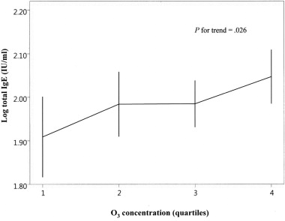

Table 1
National Prevalence of Childhood Asthma in 2013 (CDC).
Adapted from: National Current Asthma Prevalence (2013). Centers for Disease Control and Prevention (CDC).
Characteristics | Number with Current Asthma (in thousands) | Percent with Current Asthma
Total
Children (<18) | 6,109 | 8.3%
Child Age Group (in years)
0-4 | 826 | 4.2%
5-11 | 2,833 | 9.8%
12-17 | 2,449 | 9.9%
Adolescents (11-21) | 4,024 | 8.9%
Sex
Boys (Age <18) | 3,489 | 9.3%
Girls (Age <18) | 2,619 | 7.3%
Race/Ethnicity
White NH Children (Age <18) | 2,920 | 7.5%
Black NH Children (Age <18) | 1,344 | 13.4%
Other NH Children (Age <18) | 538 | 7.9%
Hispanic Children (Age <18) | 1,307 | 7.4%
Puerto Rican Children  (Age <18) | 275 | 14.6%
Mexican/Mexican American  Children (Age <18) | 690 | 5.6%

*NH- Non-Hispanic

Table 2 taken directly from Lamarque et al. (2005) displaying the emissions in gases important for the formation of ozone from 1890 to 1990.
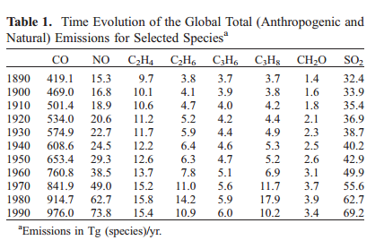

Figure 3. Direct measurements of maximum daily ozone concentrations at any monitoring site in New Jersey.
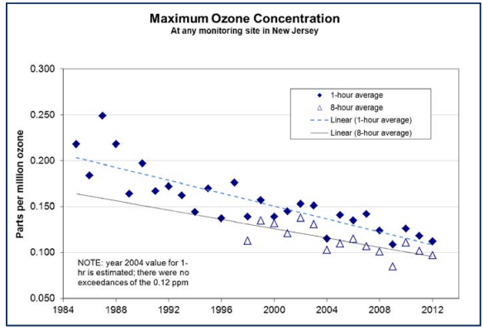

Figure 4. Average May to September ozone averaged over the northeastern United States between 1985 and 2015. Analyzed using the JRA-55 reanalysis.

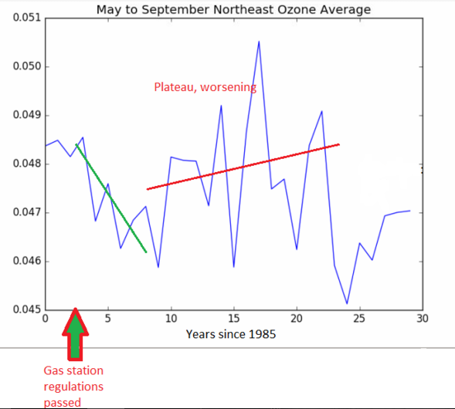

Figure 5. Northeast average temperature for May through September between 1985 and 2015.

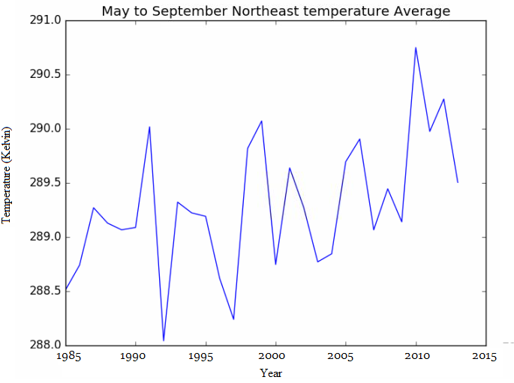

Figure 6. Average mixing ratio of ozone between May and September from 1985 to 2015.

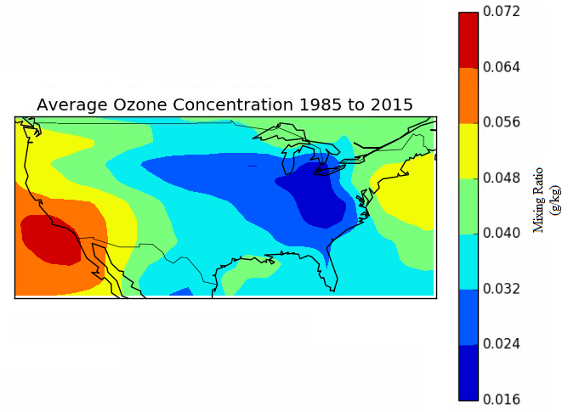

Figure 7. Ozone concentrations averaged nationally. Mixing ratio is grams/kilogram.
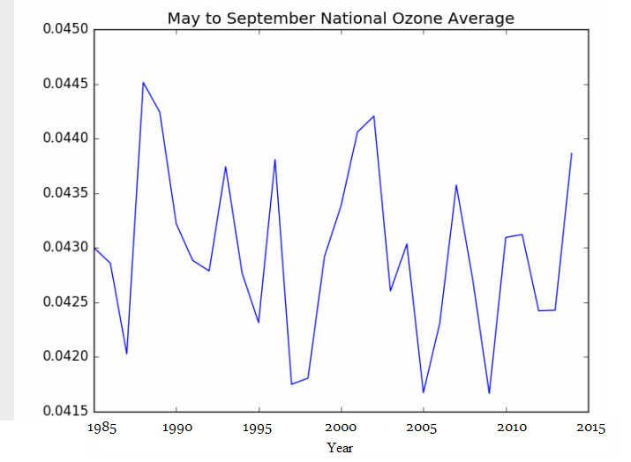

Figure 8. Averaged national temperature from 1985 to 2015.
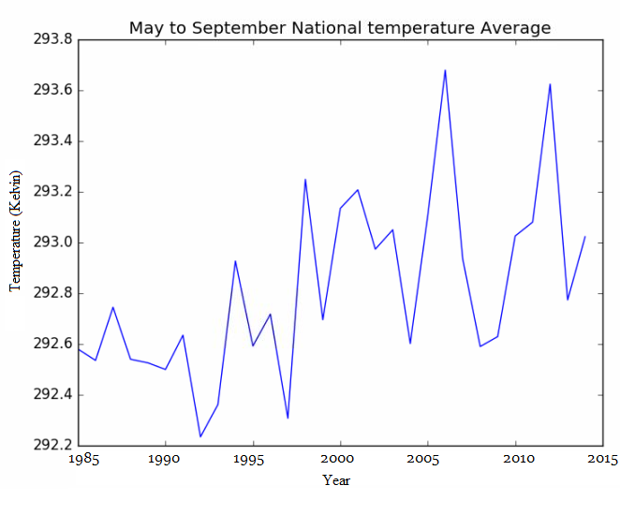

Figure 9. A linear projection of temperature through to 2035, given moderate emissions increases.
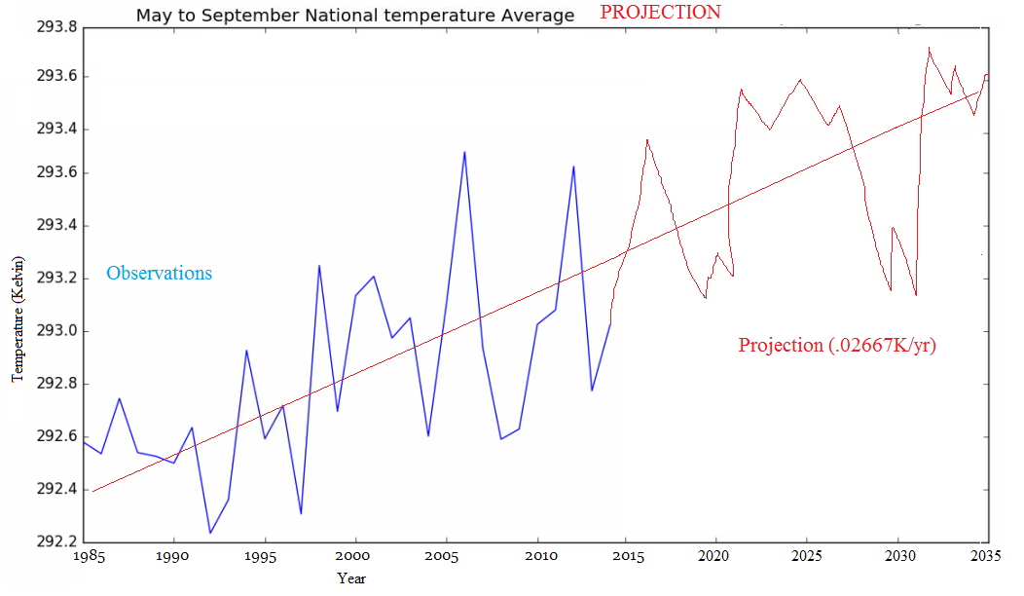

Figure 10. Projection of ozone through 2035 given variations with respect to temperature and emissions.
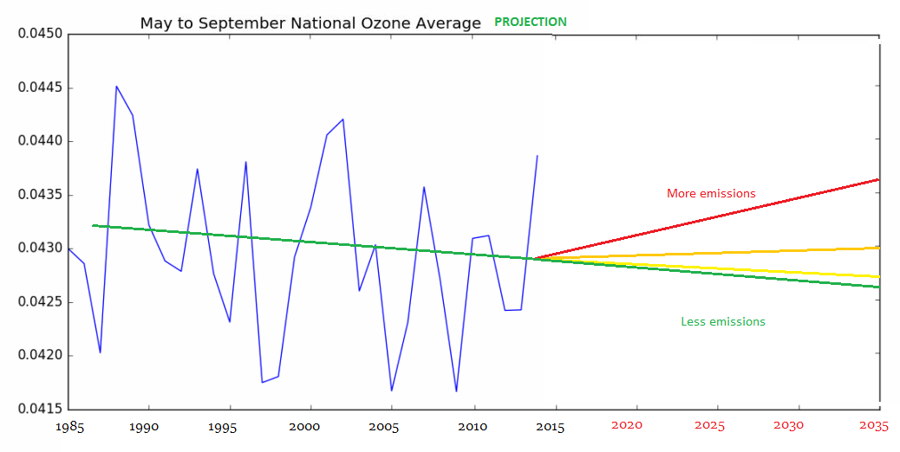

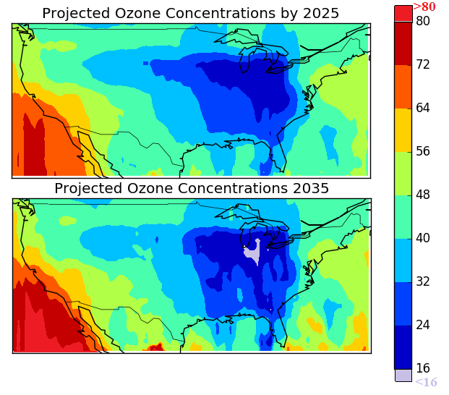
Figure 11 - Future projections of ozone nationally in parts per billion averaged between May and September.

Figure 12- Number of ER visits attributable to unhealthy ozone conditions as determined by the morbidity analysis.
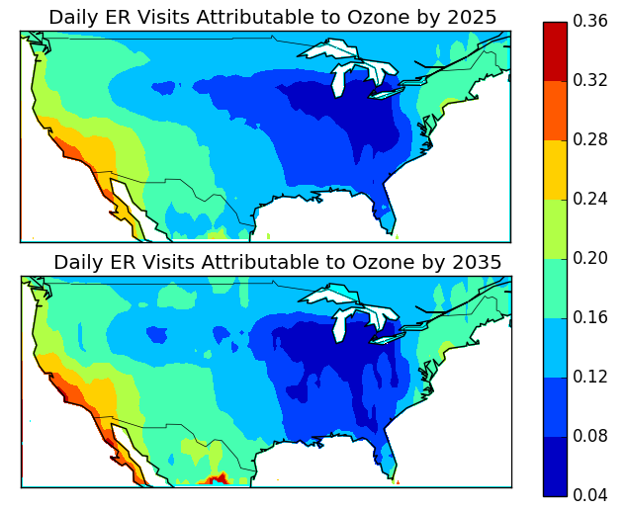

References
- Asthma Symptoms, Causes & Risk Factors. American Lung Association. lung.org/lung-health-and-diseases/lung-disease-lookup/asthma/asthma-symptoms-causes-risk-factors/
- Martinez FD, Vercelli D. Asthma. Lancet. 2013;382:1360–72.
- Asthma’s impact on the Nation, CDC http://www.cdc.gov/asthma/impacts_nation/asthmafactsheet.pdf
- Lopez, R. (2002). Segregation and black/white differences in exposure to air toxics in 1990. Environmental Health Perspectives, 110(Suppl 2), 289–295.
- S. Sousa, M. Alvim-Ferraz, F. Martins. (2013). Health effects of ozone focusing on childhood asthma: what is now known – a review from an epidemiological point of view Chemosphere, 90, pp. 2051–2058
- Allergies and the Immune System. Health Library, John Hopkins Medicine. http://hopkinsmedicine.org/healthlibrary/conditions/allergy_and_asthma/allergies_and_the_immune_system_85,P00039/
- Galli et al., (2016). Mast cells and IgE in defense against venoms: Possible “good side” of allergy? Allergology International, pg 3-15.
- Allergens and Allergic Asthma. Asthma and Allergy Foundation of America(AAFA). www.aafa.org/page/allergic-asthma.aspx
- National Current Asthma Prevalence (2013). Centers for Disease Control and Prevention (CDC).
- Kinney, P. (2008). Climate change, air quality, and human health Am. J. Prev. Med., 35,, pp. 459–467
- Kim, B.-J., Kwon, J.-W., Seo, J.-H., Kim, H.-B., Lee, S.-Y., Park, K.-S., Yu, J., (2011), Hong, S.-J. Association of ozone exposure with asthma, allergic rhinitis, and allergic sensitization. Annals of Allergy, Asthma and Immunology, 107 (3), pp. 214-219.
- Kahle JJ, Neas LM, Devlin RB, Case MW, Schmitt MT, Madden MC, Diaz-Sanchez D. (2015). Interaction effects of temperature and ozone on lung function and markers of systemic inflammation, coagulation, and fibrinolysis: a crossover study of healthy young volunteers. Environ Health Perspect 123:310–316;
- Bell, M., McDermott, A., Zeger, S. 2004. Ozone and Short-term Mortality in 95 US Urban Communties, 1987-2000. JAMA. pg 2372-2378.
- Gandhi, S. and Abramov, Y. (2012). Mechanism of Oxidative Stress in Neurodegeneration. Oxidative Medicine and Cellular Longevity, vol. 2012, Article ID 428010.
- Mustafa, M. (1990) Biochemical basis of ozone toxicity. Free Radical Biology and Medicine, Vol 9, Issue 3, pp 245-265.
- Hwang, B.F., Chen, Y., Tin, Y., Wu, X., Lee, Y. (2015) Relationship between exposure to fine particulates and ozone and reduced lung function in children. Environmental Research, Volume 137, pp 382-390.
- Valavanidis, A., Vlachogianni, T., Fiotakis, K., Loridas, S. (2013) Pulmonary Oxidative Stress, Inflammation and Cancer: Respirable Particulate Matter, Fibrous Dusts and Ozone as Major Causes of Lung Carcinogenesis through Reactive Oxygen Species Mechanisms. Int. J. Environ. Res. Public Health, 10(9), 3886-3907.
- Chen, C. et al. (2015) Effects of particulate air pollution and ozone on lung function in non-asthmatic children. Environmental Research Volume 137, pp 40-48.
- The Physics and Chemistry of Ozone. California Environmental Protection Agency (CEPA). Air Resources Board and Office of Environmental Health and Hazard Assessment. www.fraqmd.org/ozonechemistry.htm
- Seinfeld JH, Pandis SN. 1998. Atmospheric Chemistry and Physics - from Air Pollution to Climate Change. John Wiley and Sons, New York, NY.
- Finlayson-Pitts BJ, Pitts JN. (2000). Chemistry of the Upper and Lower Atmosphere - Theory, Experiments, and Applications. Academic Press, San Diego, CA.
- Lamarque, J.-F., P. Hess, L. Emmons, L. Buja, W. Washington, and C. Granier (2005), Tropospheric ozone evolution between 1890 and 1990, J. Geophys. Res., 110, D08304, doi:10.1029/2004JD005537
- Hogrefe, C., B. Lynn, K. Civerolo, J.-Y. Ku, J. Rosenthal, C. Rosenzweig, R. Goldberg, S. Gaffin, K. Knowlton, and P. L. Kinney (2004), Simulating changes in regional air pollution over the eastern United States due to changes in global and regional climate and emissions, J. Geophys. Res., 109, D22301, doi:10.1029/2004JD004690.
- Sekiya, T., and K. Sudo (2014), Roles of transport and chemistry processes in global ozone change on interannual and multidecadal time scales, J. Geophys. Res. Atmos., 119, 4903–4921, doi:10.1002/2013JD020838.
- S. Trivikrama Rao , Gopal Sistla & Robert Henry (1992) Statistical Analysis of Trends in Urban Ozone Air Quality, Journal of the Air & Waste Management Association, 42:9, 1204-1211.
- Weisel, C, Cody, P. R., Lioy, P. (1995). Relationship between Summertime Ambient Ozone Levels and Emergency Department Visits for Asthma in Central New Jersey. Environmental Health Perspectives, 97-102.
- U.S. EPA . Final Ozone NAAQS Regulatory Impact Analysis. EPA-452/R-08-003. U.S. Environmental Protection Agency; Research Triangle Park, North Carolina: 2008.
- Ozone (2012). Environmental Trends Report, NDEP, Office of Science. http://www.nj.gov/dep/dsr/trends/pdfs/ozone.pdf
- NOx and VOC Emission Trends (2011). Environmental Trends Report, NDEP, Office of Science. www.nj.gov/dep/dsr/trends/pdfs/nox-voc.pdf
- Stieb DM, Burnett RT, Beveridge RC, Brook JR. Association between ozone and asthma emergency department visits in Saint John, New Brunswick, Canada. Environ Health Perspect. 1996 Dec;104(12):1354–1360.
- Sheffield, P. E., Knowlton, K., Carr, J. L., & Kinney, P. L. (2011). Modeling of Regional Climate Change Effects on Ground-Level Ozone and Childhood Asthma. American Journal of Preventive Medicine, 41(3), 251–257.
- State of the Air (2016). American Lung Association. www.lung.org/assets/documents/healthy-air/state-of-the-air/sota-2016-full.pdf

