Analysis of the effect of Eurasian snow cover on North American winter temperatures

Joshua Coupe
Physical Climatology

Introduction

Forecasts on the seasonal to year timescale are heavily reliant on long term modes of variability, such as the Arctic Oscillation, also known as the AO. The AO is defined as the first mode of the EOF of northern hemisphere monthly mean sea level pressure (Itoh, 2008). The AO effectively measures the relative intensity of pressure at the north pole, a proxy for zonal mean winds. A negative AO would indicate higher pressure at the pole and weaker zonal winds while a positive AO would indicate lower pressure and stronger zonal winds (Ambaum et al., 2001). The AO is considered to be the dominant mode of northern hemisphere winter variability and is the parent of the North Atlantic Oscillation (NAO), which forces similar atmospheric circulation patterns (Itoh, 2008). The NAO is the difference in pressure between the Icelandic Low and the Azores High, where a negative phase indicates a weak pressure gradient and a meandering jet stream across the North Atlantic, a positive phase indicates a strong pressure gradient and a laminar jet stream (Wallace and Gutzler, 1981; Ambaum et al., 2001). There is much debate as to whether the NAO and AO are just different manifestations of the same phenomenon or are identical modes of variability. For the purposes of this paper, the sole concern is their ability to influence North American temperatures via atmospheric dynamics that begin in Eurasia.

The AO and NAO are modulated by a number of internal and external variables such as North Atlantic SSTs, SSTs in the equatorial Indian and western Pacific Oceans, and greenhouse gases (Allen and Zender, 2011; Shindell et al. 1999; Cohen and Entekhabi, 1999; Saito and Cohen, 2003). Snow cover has been observed to have a negative effect on surrounding air temperatures, leading to significant scientific inquiry into the possibility of large remote areas of anomalous snow cover having climate teleconnections (Wagner, 1973). Observational studies within the past decade have examined Eurasian snow cover and determined a significant link likely exists between Eurasian snow cover and the phase of the AO (Allen and Zender, 2011; Cohen and Barlow, 2005).

In theory, a large area of higher than average snow cover in Eurasia acts as an anomalous heat sink and assists in the development of the coldest air mass in the northern hemisphere. Topographically generated Rossby waves in the troposphere are impacted by this change in energy balance and interact with the stratosphere, allowing for a coupled troposphere-stratosphere response (Saito, Cohen, and Entekhabi, 2001; Allen and Zender, 2011). Rossby wave propagation occurs both upwards and downwards in the atmospheric column, indicating a dynamic relationship between the surface cooling and the upper level Rossby waves feeding back on each other. The slowing down of the stratospheric polar vortex promotes anticyclogenesis and as the coupled troposphere-stratosphere response propagates downwards towards the surface with weaker zonal winds, a negative AO manifests itself (Saito, Cohen, and Entekhabi, 2001; Allen and Zender, 2011; Kuroda and Kodera, 1999). Because the AO modulates temperatures across the northern hemisphere, a link between anomalous snow cover and the AO would result in a recurring temperature signature in North America for every year with above average snow cover. This paper aims to show both the link between Eurasian snow cover and North American temperatures and demonstrate the existence of a pathway for this to occur.

Data

To determine the nature of the correlation between Eurasian snow cover and North American temperatures, NH SCE CDR v01r01 is employed, a comprehensive northern hemisphere snow cover extent dataset from November 1966 to November 2016. Snow cover extent is defined as the areal snow cover for Europe and Asia in millions of square kilometers. Due to gaps in coverage before 1971, the period September 1972 to January 2015 is used. For 2m monthly mean temperatures, GHCN_CAMS Gridded 2m Temperature reanalysis is used. At 2.5 degree resolution, it spans from January 1948 to November 2016 and contains global temperatures. An NCEP reanalysis spanning the same timescale and a 2.5 degree resolution is used for monthly mean 500mb geopotential heights (Kalnay et al., 1996).

Theoretically, SON snow cover influences DJF temperatures over North America due to propagating Rossby waves. A lag is incorporated into the analysis due to the timescale at which Rossby waves propagate over entire continents by comparing autumn (SON) snow cover with the winter (DJF) variables affected by snow cover. As Eurasian snow cover builds in autumn, the Siberian high undergoes anticyclogenesis and cold air expands across the continent (Cohen and Entekhabi, 1999). Due to topographical effects, the cold air is forced westward into Europe and northward across the North Pole over a period of a few weeks. As the cold air moves over eastern North America it displaces the Icelandic Low, initiating the negative phase of the NAO (AO) as December approaches. The correlations between autumnal Eurasian snow cover and winter North American temperatures and 500mb geopotential heights help to determine the atmospheric circulation pattern forced by anomalous snow cover.

Results
a. ) SON Eurasian snow cover correlated with DJF North American surface temperatures
The normalized time series of SON Eurasian snow cover area over the period 1972 to 2015 is shown in Figure 1. Between 1977 and 1992, snow cover area exhibited below normal coverage, and contrarily between 1995 and 2015 Eurasian snow cover area trends higher. Figure 2 shows the correlation value between North American DJF temperatures and Eurasian SON snow cover. In general, DJF surface temperatures on the west coast of the United States are positively correlated with SON Eurasian snow cover area, if only weakly. Heading east, there is an even weaker negative correlation of temperatures with snow cover, indicating that increasing Eurasian snow cover leads to cooler air temperatures, but the relationship is not strongly correlated. The surface temperatures on the south Greenland coast are positively correlated with Eurasian snow cover, at a similar magnitude to the west coast of the United States. This is similar to a negative AO, although not every feature in this correlation map is representative of a negative AO. There are likely other influences that modulate both Eurasian snow cover and North American temperatures that could be captured in this analysis, such as the Pacific/North American pattern, or PNA.

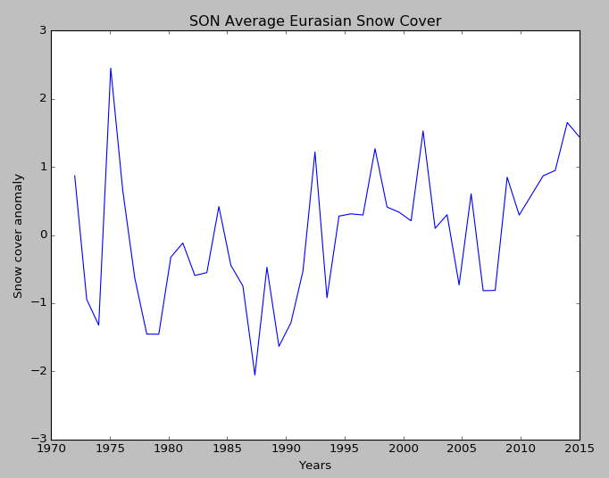
Figure 1. Standard deviation of the departure from mean 1972-2015 SON Eurasian snow cover.

Figure 2. Correlation coefficient between 1972-2015 DJF 2m temperatures and SON averaged yearly Eurasian snow cover for North America.

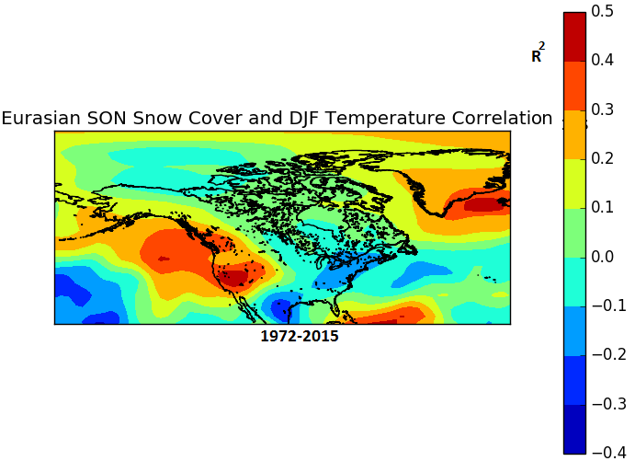

b. ) SON Eurasian snow cover correlated with DJF North American 500mb geopotential heights
Using the same time series as in Figure 1, a regression at every 2.5 degree gridpoint in the North American region is performed for DJF 500mb geopotential heights and SON Eurasian snow cover. 500mb geopotential heights are often the vehicle for Rossby wave propagation, which is the hypothetical mechanism for Eurasian snow cover influence on North American temperatures. Figure 3 shows the regression between 500mb geopotential heights and Eurasian snow cover. Although the correlation coefficients are relatively low, four hypothetical Rossby waves are portrayed. The negatively correlated Eurasian snow cover with 500mb geopotential heights demonstrates a tendency for above average SON Eurasian snow cover to induce lower geopotential heights, which is often associated with lower temperatures and more precipitation. The positively correlated west coast of the United States indicates ridging with higher snow area. This positive correlation extends further south into the tropics, into a region that was not expected to strongly correlate to polar circulation changes. Finally, on the east coast of the United States is a weakly correlated signal of lower geopotential heights with higher snow cover.
Figure 3. Correlation coefficient between 1972-2015 DJF 500mb geopotential heights and SON averaged yearly Eurasian snow cover for North America.
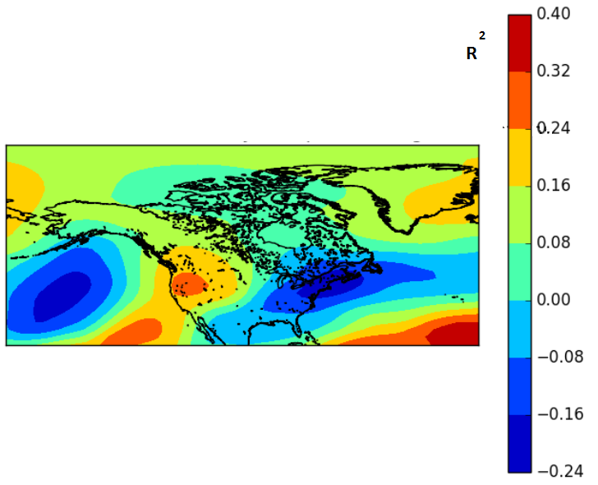

The geopotential height pattern as described in Figure 3 closely resembles a negative AO despite the ridging tendencies on the west coast of the United States. This difference resembles the positive phase of the PNA with ridging in the west and a trough in the east, but it is not clear how Eurasian snow cover influences the PNA. Hu et al. (2001) found that autumn Eurasian snow cover had an influence on PNA-like variability during the winter months where higher Eurasian snow cover led to a deepening of the Aleutian Low. The deepened Aleutian low structure is seen in the correlation map, giving greater credibility to the Eurasian snow cover and PNA connection. The influence of Eurasian snow cover on the PNA through a deepening Aleutian Low, however, has not been widely studied.
c) 5 largest Eurasian SON snow areal extent anomalies
To understand the mechanism of anomalous snow cover influencing atmospheric circulations, DJF temperature and 500mb geopotential height composites of the years with the highest average SON snow cover areal extent were created to find a stronger signal. The reasoning was that the years with the greatest snow cover would force the strongest response into the atmosphere. Temperatures and geopotential heights for the years 1975, 1997, 2001, 2013, and 2014 were averaged together as seen in Figures 4a and 4b. While some aspects were stronger, there were unexpected differences. A very strong western Atlantic ridge was present with below geopotential heights restricted to eastern Canada and the north central United States. Warm temperatures across the east coast indicated that another climate mode other than the AO was likely exerting a lot of influence. The Arctic regions for the most part experienced higher than normal geopotential heights, which is consistent with a -AO. Additionally, temperatures were more than 1 standard deviations above normal in the polar regions. The west coast experienced ridging over this set of years as well, which has has been a feature in every scenario. This evidence shows that Eurasian snow cover is almost certainly forcing the PNA pattern. Finally, it appears that there exists a maximum threshold of Eurasian snow cover where the AO signal stops being amplified, so that the highest snow cover area years do not necessarily create the highest amplitude -AO signal. Otherwise, the ridge over the eastern United States would not overwhelm the typical AO structure.

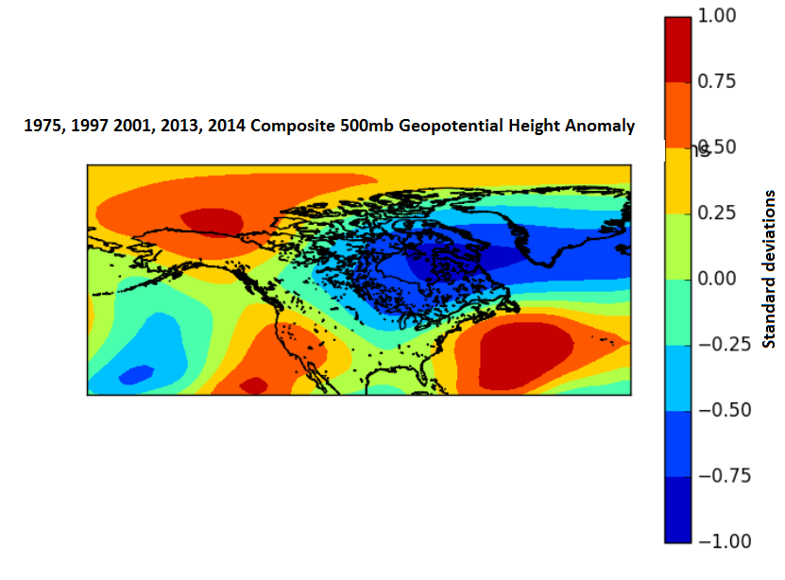
Figure 4a. Composite of DJF 500mb geopotential height anomaly from 1975, 1997, 2001, 2013, 2014.

Figure 4b. Composite of DJF temperature anomaly from 1975, 1997, 2001, 2013, 2014
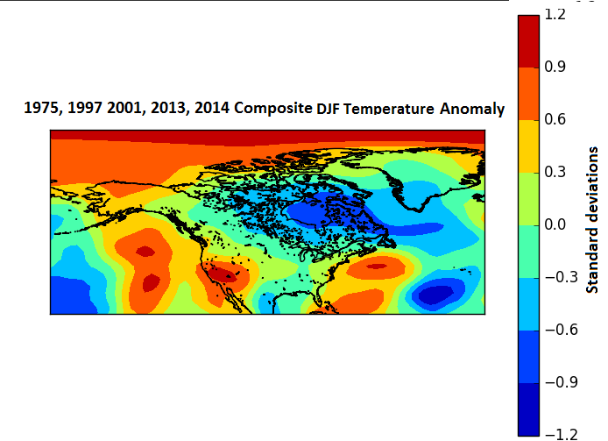

Discussion
The response of above average Eurasian snow cover in the atmosphere may have been weak in this analysis on a point by point basis, but an undeniable trend in structures has been shown to exist. The spatial structure of geopotential height and temperature anomalies demonstrates that although the correlation coefficients were weak, there is a trend towards -AO atmospheric conditions with increasing Eurasian snow cover in autumn. Additionally, there was a trend towards +PNA conditions as evidenced by consistent ridging on the western coast of the United States and a deepening Aleutian Low with increasing Eurasian snow cover. Not considered was the influence of other long term climate modes impacting Eurasian snow cover or North American geopotential heights/temperatures in a similar way. Without accounting for ENSO or the PDO, the correlation between Eurasian snow cover and North American winter climate is most likely dampened.

Seasonal forecasts require the incorporation of not just the known climate modes, but including climate variability not yet understood. The accuracy of seasonal forecasts remains low, but can only improve with a greater understanding of the way Eurasian snow cover can influence North American atmospheric circulations. A thorough investigation into the PNA would be the next step in determining the precise way that the atmosphere responds to above average Eurasian snow cover. Future analyses would control for ENSO and the PDO to assess how variability in the Pacific Ocean is impacting the signal of Eurasian snow cover on North American winter climate.

References

Allen, R. J., Zender, C. S, 2011. Forcing of the Arctic Oscillation by Eurasian Snow Cover. Journal of Climate., Vol. 24, 6258-6539.

Ambaum, M., Hoskins, B., Stephenson, D., 2001. Arctic Oscillation or North Atlantic Oscillation. Journal of Climate, Vol 14. 3495-3507.

Cohen, J., and M. Barlow, 2005: The NAO, the AO, and global warming: How closely related? J. Climate, 18, 4498–4513.

Cohen, J., and D. Entekhabi, 1999: Eurasian snow cover variability and Northern Hemisphere climate predictability. Geophys. Res. Lett., 26, 345–348.

Itoh, H., 2008. Reconsideration of the True versus Apparent Arctic Oscillation. Journal of Climate. Vol 21. 2047 - 2062.

Kalnay et al., 1996. The NCEP/NCAR 40-year reanalysis project, Bull. Amer. Meteor. Soc., 77, 437-470.

Kuroda, Y. and Kodera, K., 1999. Role of Planetary Waves in the Stratosphere-troposphere Coupled Variability in the Northern Hemisphere Winter. Geophysical Research Letters, Vol. 26, No.15, 2375-2378.

Robinson, David A., Estilow, Thomas W., and NOAA CDR Program (2012):NOAA Climate Date Record (CDR) of Northern Hemisphere (NH) Snow Cover Extent (SCE), Version 1.. NOAA National Climatic Data Center. doi:10.7289/V5N014G9.

Saito, K., and J. Cohen, 2003: The potential role of snow cover in forcing interannual variability of the major Northern Hemisphere mode. Geophysical Research Letters, 30, 1302.

Saito, K., and J. Cohen., and D. Entekhabi, 2001: Evolution of atmospheric response to early-season Eurasian snow cover anomalies. Monthly Weather Review., 129, 2746-2760.

Shindell, D. T., R. L. Miller, G. A. Schmidt, and L. Pandolfo, 1999: Simulation of recent northern winter climate trends by greenhouse-gas forcing. Nature, 399, 452–455.

Wagner, J. A., 1973: The influence of average snow depth on monthly mean temperature anomaly. Mon. Wea. Rev., 101, 624-626.

Wallace, J. M. and Gutzler, D. S., 1981. Teleconnections in the Geopotential Height Field During the Northern Hemisphere Winter. Monthly Weather Review, Vol 109. 784-790.

Wu, Q., Hu, H., and Zhang, L., 2011. Observed Influences of Autumn-Early Winter Eurasian Snow Cover Anomalies on the Hemispheric PNA-like Variability in Winter. Journal of Climate, Vol. 24. 2017-2032.

